 |  | AMERICAN INTERNATIONAL UNIVERSITY – BANGLADESH  Faculty of Engineering
Lab Name: |  |  | Digital Logic and Circuits Lab
Semester: Fall 2024-25 |  |  |  | Term: Mid | Quiz: Performance | Total Marks: 20 | Time: 1.5 hrs

Question Mapping with Course Outcomes:
Item | COs | POIs | K | P | A | Marks | Obtained Marks
Q1 | CO3 | P.e.2.P4 | K3 | P1, P4, P5 |  | 20
Total: |  |  |  |  |  | 20

Student Information:
Student Name: | Afnan Bin Islam Nahin | Student ID: | 22-49350-3
Section: | I | Department: | CSE
(Group distribution will be given during Exam time)
Group | Task to be implemented and verify*
"In a manufacturing plant, there are four different machines, each controlled by a designated switch. The assembly line machine is operated by Switch A, the packaging machine by Switch B, the quality control machine by Switch C, and the delivery machine by Switch D. The production process starts if the worker activates the switch for the delivery machine (D), or if switches for both the assembly line machine (A) and the quality control machine (C) are activated simultaneously, or if switches for the packaging machine (B) and the quality control machine (C) are activated simultaneously.
Using truth tables, Karnaugh Maps, and logic gates, determine the conditions necessary to start the production process, reduce the expression, and design the circuit accordingly."

Abstract:

The goal of this experiment is to see how logic circuits drawn from a given statement are implemented on a breadboard using gate ICs and whether or not the output validates the truth table of the provided logic statement. Also, study about Boolean algebra and De Morgan's law. The equations were solved using K-Map, and the correctness was verified by breadboard implementation and Multisim simulation.

Introduction:
In contemporary manufacturing plants, efficient and dependable control systems are critical for smooth operations. Logic circuits play an important role in automating such processes by ensuring that certain workflows are activated in response to predetermined criteria. This experiment investigates the design of a control system for a manufacturing facility that includes four machines: assembly line (A), packing (B), quality control (C), and delivery (D). The goal is to create a logic circuit that starts the manufacturing process depending on certain criteria. Building a truth table is the first step in this procedure, after which a standard SOP is determined. Simultaneously, by examining the logic operations done in the circuit and comparing them with their matching logic gates, a logic expression can also be obtained from a particular combinational circuit layout. This includes analyzing the problem, developing a truth table, utilizing Karnaugh Maps to simplify the logic statement, and building the circuit.

Theory and Methodology:
Combinational circuits are built with logic gates and other components. The following steps are as follows:
If a problem statement is given, the following steps will help design the system

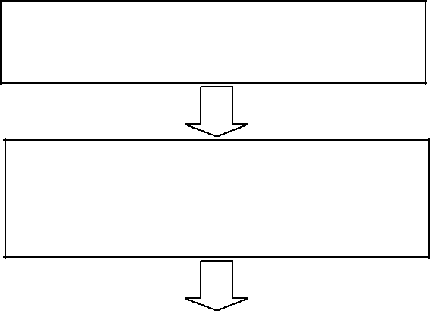

Look for the problem statement

Find the input(s) and output(s) of the

system and relate the input(s) with the

output(s)

Develop a truth table for your system
Develop a truth table for your system using the input and output relationship that you have established

using the input and output
relationship that you have established
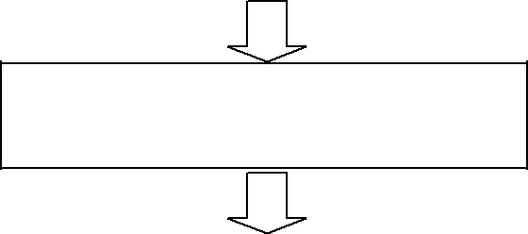
From your truth table, generate a
standard output expression

From your truth table, generate a
standard output expression
Reduce/simplify the output expression
using Boolean algebra or K-Map

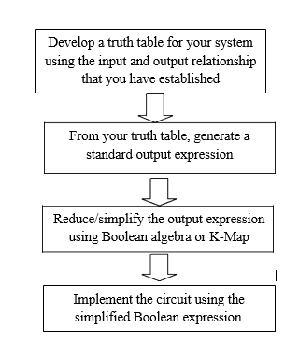

Standard SOP expressions are important in constructing truth-tables and in Karnaugh map simplification method. The SOP expression is equal to 1 only if one or more of the product terms in the expression is equal to 1. Standard POS expression is one in which all the variables in the domain appear in each sum term in the expression. A Karnaugh map is similar to a truth table because it presents all of the possible values of input variables and the resulting output of each valued. Instead of being organized into columns and rows like truth table, the Karnaugh map is an array of cells in which each cell presents binary value of the input variables. The cells are arranged in a way so that the simplification of a given expression is simply a matter of properly grouping the cells. Karnaugh maps can be used for expressions with two, three, four and five variables. The number of cells in a Karnaugh map is equal to the total number of possible input variable combinations as is the number of rows in a truth table.

Equipment & materials:

Experimental procedure:
  - A truth table was drawn to represent the Y output.
  - The output of the truth table was used to generate standard SOP expressions.
  - The SOP expression was minimized using Boolean algebra and K-map. Perform the hardware implementation of the circuit and compare the output with your truth table.
Data and Results:

Truth Table:

Switch A | Switch B | Switch C | Switch D | Output
A | B | C | D | Y
0 | 0 | 0 | 0 | 0
0 | 0 | 0 | 1 | 1
0 | 0 | 1 | 0 | 0
0 | 0 | 1 | 1 | 1
0 | 1 | 0 | 0 | 0
0 | 1 | 0 | 1 | 1
0 | 1 | 1 | 0 | 1
0 | 1 | 1 | 1 | 1
1 | 0 | 0 | 0 | 0
1 | 0 | 0 | 1 | 1
1 | 0 | 1 | 0 | 1
1 | 0 | 1 | 1 | 1
1 | 1 | 0 | 0 | 0
1 | 1 | 0 | 1 | 1
1 | 1 | 1 | 0 | 1
1 | 1 | 1 | 1 | 1

- SOP Equation:
Y = A’ B’ C’ D + A’ B’ CD + A’B C’ D + A’ BC D’ + A’ BCD + A B’ C’D + AB’ C D’ + A B’
CD + AB C’ D + ABCD’ + ABCD

- POS Equation:
Y = (A + B + C + D) (A + B + C’ + D) (A + B’ + C + D) (A’ + B+ C + D) (A’ + B’+ C + D)

K-MAP:

CD  AB | 00 | 01 | 11 | 10
00 | 0 | 1 | 1 | 0
01 | 0 | 1 | 1 | 1
11 | 0 | 1 | 1 | 1
10 | 0 | 1 | 1 | 1

Group1 =D Group2=BC Group3=AC

So, K-Map Expression, Y = D + BC + AC = D + C (A + B)

SOP expression minimize state:
Y = D + BC + AC
= D + C (A + B)

Simulations:
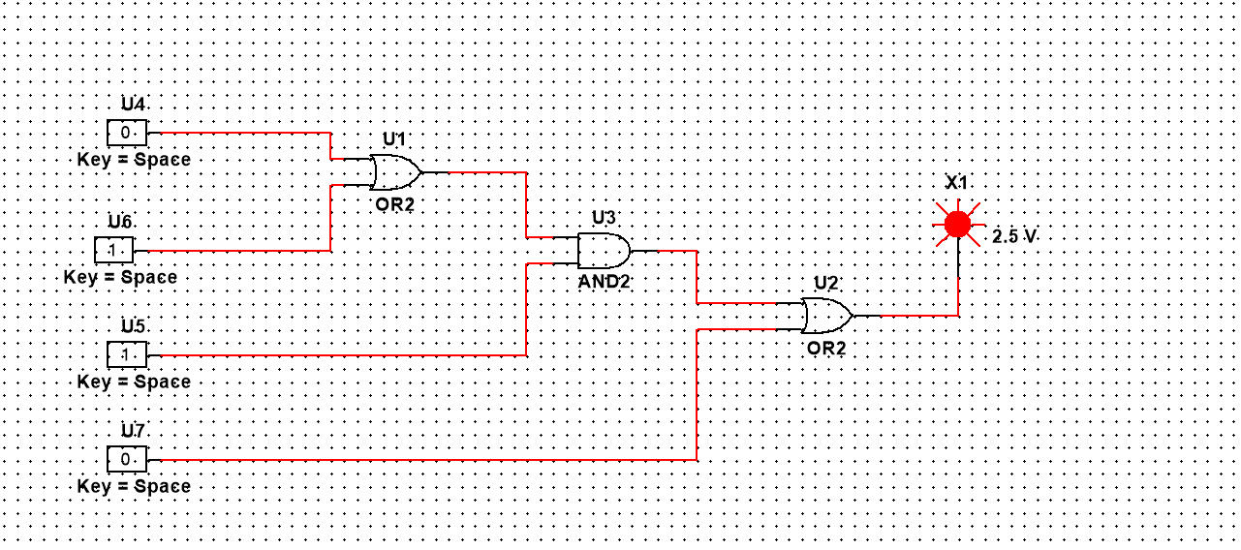

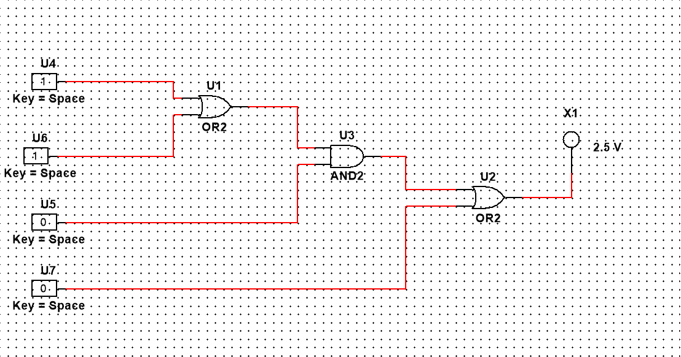

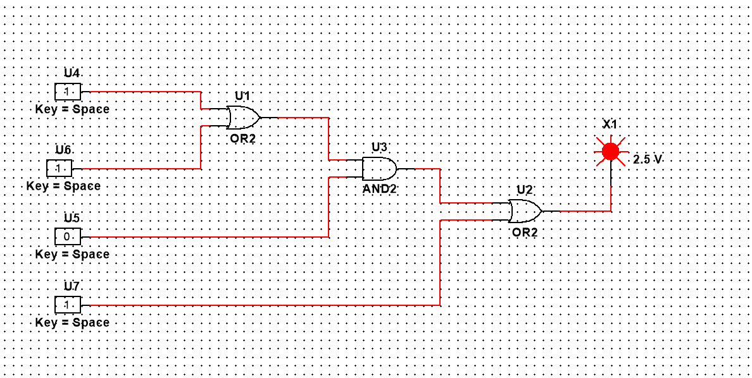

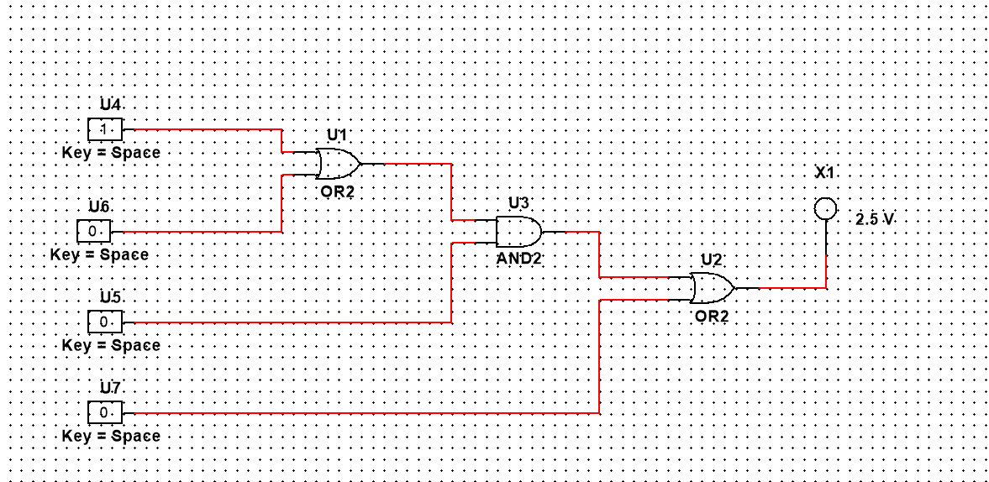

Discussion :
In the experiment, resulting equations were simplified and implemented on a trainer board utilizing integrated circuits (ICs) with the requisite gates. ICs and pins were properly connected, and gates were correctly biassed. Power was applied to the circuit, and inputs were provided by powering the gate's input pins. Inputs were provided in accordance with the matching truth table, and the result was viewed and compared. The circuit's output perfectly matched the generated truth table's output, as did the supplied assertion. Thus, the resulting equation and truth tables were valid, and the reduced equation was right.

Conclusion:

The goal of this exercise was to learn how to create logic circuits generated from a given statement on a breadboard using gate ICs and to determine whether or not the output verified the truth table of the supplied logic statement. The experiment was completed successfully in both the lab and Multisim. All expressions were validated using their truth tables. Although the experiment was successful, there are several improvements that may be made to the study's design, implementation, and outcomes.

Assessment Materials and Marks Allocation:
COs | Assessment Materials | POIs | Marks
CO3 | Apply concepts of digital logic design and logic gates to design, implement, simulate, and demonstrate different types of digital electronic circuits using various hardware and software tools as if the problems are complex in nature. | P.e.2.P4 | 20

COs | Excellent to Proficient  [15-20] | Good  [10-14] | Acceptable  [5-9] | Unacceptable  [1-4] | No Response  [0] | Secured Marks
CO3  P.e.2.P4 | Demonstrates a high level of proficiency in utilizing logic ICs, transistors, switches, measurement tools, etc., to solve complex engineering problems in digital electronic circuits. Outcomes are appropriate, well-modeled, and consistently valid, showing a clear understanding of digital logic design. | Shows a good understanding of logic ICs, transistors, switches, and display devices with reasonable success in solving complex engineering problems in digital electronic circuits. Modeling and outcomes are generally valid but may lack some precision. | Displays basic understanding of logic ICs, transistors, switches, and display devices but struggles to solve complex engineering problems fully. Modeling may show partial validity but lacks in achieving complete, accurate outcomes. | Performance does not demonstrate understanding of key components like logic ICs and transistors, fails to solve complex engineering problems, and outcomes are inappropriate or invalid. | No attempt or response.
Comments |  |  |  |  | Total Marks (20)

Marks:

SL # | ID | Student Name | Department | Marks

